LaGrange Academy
Reading Assignment for Rising Third Graders
Summer 2023

Your rising third grader should independently read at least 3 chapter books this summer. The following books are popular with boys and girls entering third grade. Please do not limit your child to this list. Other authors and books offer enjoyable reading. It is important to select books on your child’s reading level. Read and record the book title and author on the record sheet. Students should return the record sheet upon returning to school.

Adler, David A. Cam Jansen books

Bentley, Sue Magic Puppy series

Betancourt, Jeanne Pony Pals series

Brown, Jeff Flat Stanley books
Christopher, Matt Sport-themed books

Cleary, Beverly Books about family and kids (e.g. Ramona Quimby)

Cole, Joanna Magic School Bus Chapter Books
Dadey, Debbie Bailey School Kids

Klein, Abby Ready, Freddy! books

Keene, Carolyn Nancy Drew and the Clue Crew books
Kline, Suzy Horrible Harry books
Krulik, Nancy Katie Kazoo books
Martin, Ann M. Baby-Sitters Club books
McDonald, Megan Judy Moody series
Meadows, Daisy Rainbow Magic Fairy books
Miles, Ellen Puppy Place and Kitty Corner books
Osborne, Mary Pope Magic Tree House books
Park, Barbara Junie B. Jones books
Preller, James Jigsaw Jones mystery books
Roy, Ron A to Z Mysteries series

Sobol, Donald J. Encyclopedia Brown books
Stilton, Geronimo Mouse detective mystery book series
Warner, Gertrude Boxcar Children series

3rd Grade
Summer Reading Record

Reading is one of the greatest gifts we have!
You may always read more than 3 books!

ENJOY!!!!

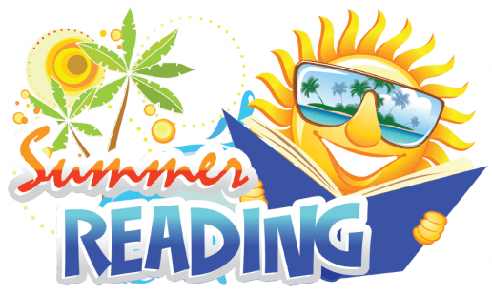

Student Name_________________________________

Title of Book Author

1. (Required)_____________________________________________________________________________

2. (Required)_____________________________________________________________________________

3. (Required)_____________________________________________________________________________

4. _____________________________________________________________________________________

5. _____________________________________________________________________________________

6. _____________________________________________________________________________________

7. _____________________________________________________________________________________

8. _____________________________________________________________________________________

9. _____________________________________________________________________________________

10. ____________________________________________________________________________________

My child has read the above books this summer.

_______________________________________
Parent/Guardian Signature

To Parents of rising 3rd Graders:

Please encourage your child to read as much as possible this summer. Reading for pleasure is an acquired taste and although some children acquire this taste quite early, others take awhile to discover their reading niche. Summer would be a great time to explore different genres, writing styles, authors, and book series.

Here are some ways to encourage your child to read this summer:

1. Take them to the local library. Enjoy the quiet atmosphere, the air-conditioning, and the variety of books and
magazines available.

2. Encourage your child to read a variety of print—encyclopedias, maps, reference books, magazines, road signs,
restaurant menus, travel brochures, recipes, poetry, newspapers, manuals, dictionaries.

3. READ ALOUD TO YOUR CHILDREN! Yes, your child is becoming an independent reader, but the bedtime story is
still a worthy ritual to be revisited. You might introduce a daytime-story-reading ritual as well. Reading literature that
is a couple of grade levels above your child’s reading level is fine too.

4. Have your child read to you. Take an interest in your child’s book and ask them to read out loud to you. This will
enhance fluency and strengthen comprehension. When children become smoother, more accurate readers, they will
become more knowledgeable readers. Research shows that when children read expressively, they show a greater
understanding of the text.

5. Be a role model for reading. One of the best ways to encourage your child to read is for your child to see you
reading.

6. Take advantage of audio books while traveling this summer. Hearing a well-read story is a great way to foster a love
of good literature. Make it a shared experience in the car.

Happy summer and happy reading!

Mrs. Miller

